**Business Insight and ANALYSIS REPORT FOR GLASGOW**

**Table of Contents**

Introduction……………………………………………………………………………………………………1

Data Description……………………………………………………………………………………………..2

Methodology…………………………………………………………………………………………………12

Results…………………………………………………………………………………………………………..14

Discussion………………………………………………………………………………………………………15

Conclusion……………………………………………………………………………………………………..16

References…………………………………………………………………………………………………….17

**Introduction**

Glasgow has a population of over 600,000 people [1]. This population is projected to rise in the coming years. Migration, both national and international, is attributed as the main driver of this growth [2]. This rapid population growth brings with it a lot of new opportunities within the city of Glasgow for businesses to cater to a wider variety of clientele.

Most of the Glasgow population is clustered around the city centre which is the main hub of economic activity. Glasgow also has a very reliable public transport system. According to the SPT Subway survey, 97% of subway commuters report overall satisfaction [3]. Therefore, subways are a popular mode of transport for the local population trying to commute within the city. 13.1 million subway passenger journeys were recorded in the 2018 to 2019 period [4].

So, areas close to the city centre (~ 5 km from the city centre) and close to a subway station (~ 2 km from the nearest subway station) offer businesses a great deal of opportunity and exposure to a wide customer base. So, these areas are ideal places to start a new business. In Glasgow’s highly competitive business environment, identifying business opportunities and choosing the optimum location is a pivotal decision for new small businesses. Choosing the right location can have considerable impact on future profits and prospects for a business.

Therefore, this project aims to provide data driven insight to businesses by identifying possible business opportunities within Glasgow and the ideal location (postal district) for those business opportunities. The project will use venue information acquired using the FourSquareAPI to identify the most common venues within each postal code. The total population and their ethnicities are also acquired using datasets from the Glasgow City Council and the Royal mail. Insight from this data will allow postal codes to be clustered according to the most common venues and their population characteristics. This will offer insight and analysis into the type of business competition at each postal code and possible untapped business opportunities within Glasgow.

**Data Description:**

In order to complete this project five data sets are used. The datasets come from three sources, web pages, publicly available datasets and FourSquareAPI.

**Dataset 1:** The list of all postal codes in Glasgow with their latitude and longitude information. This data set is a combination of data acquired from the Web and the FourSquareAPI.

This dataset is scraped from the Wikipedia page given in [5]. It contains the following parameter information for the 56 G category postal codes.

* Postcode district
* Post town
* Coverage
* Local authority area

The dataset is processed. The non-geographical postal codes are removed. This reduces the postcode to 50 valid entries. A new column is added to the dataset, called ‘District’. The District is the first coverage area. In order to find the latitude and longitude information of these 50 entries, the postcode and the corresponding district are feed into the geolocator.geocode function that uses the FourSquare agent. The function to find the latitude and longitudes of the postal codes is given below.

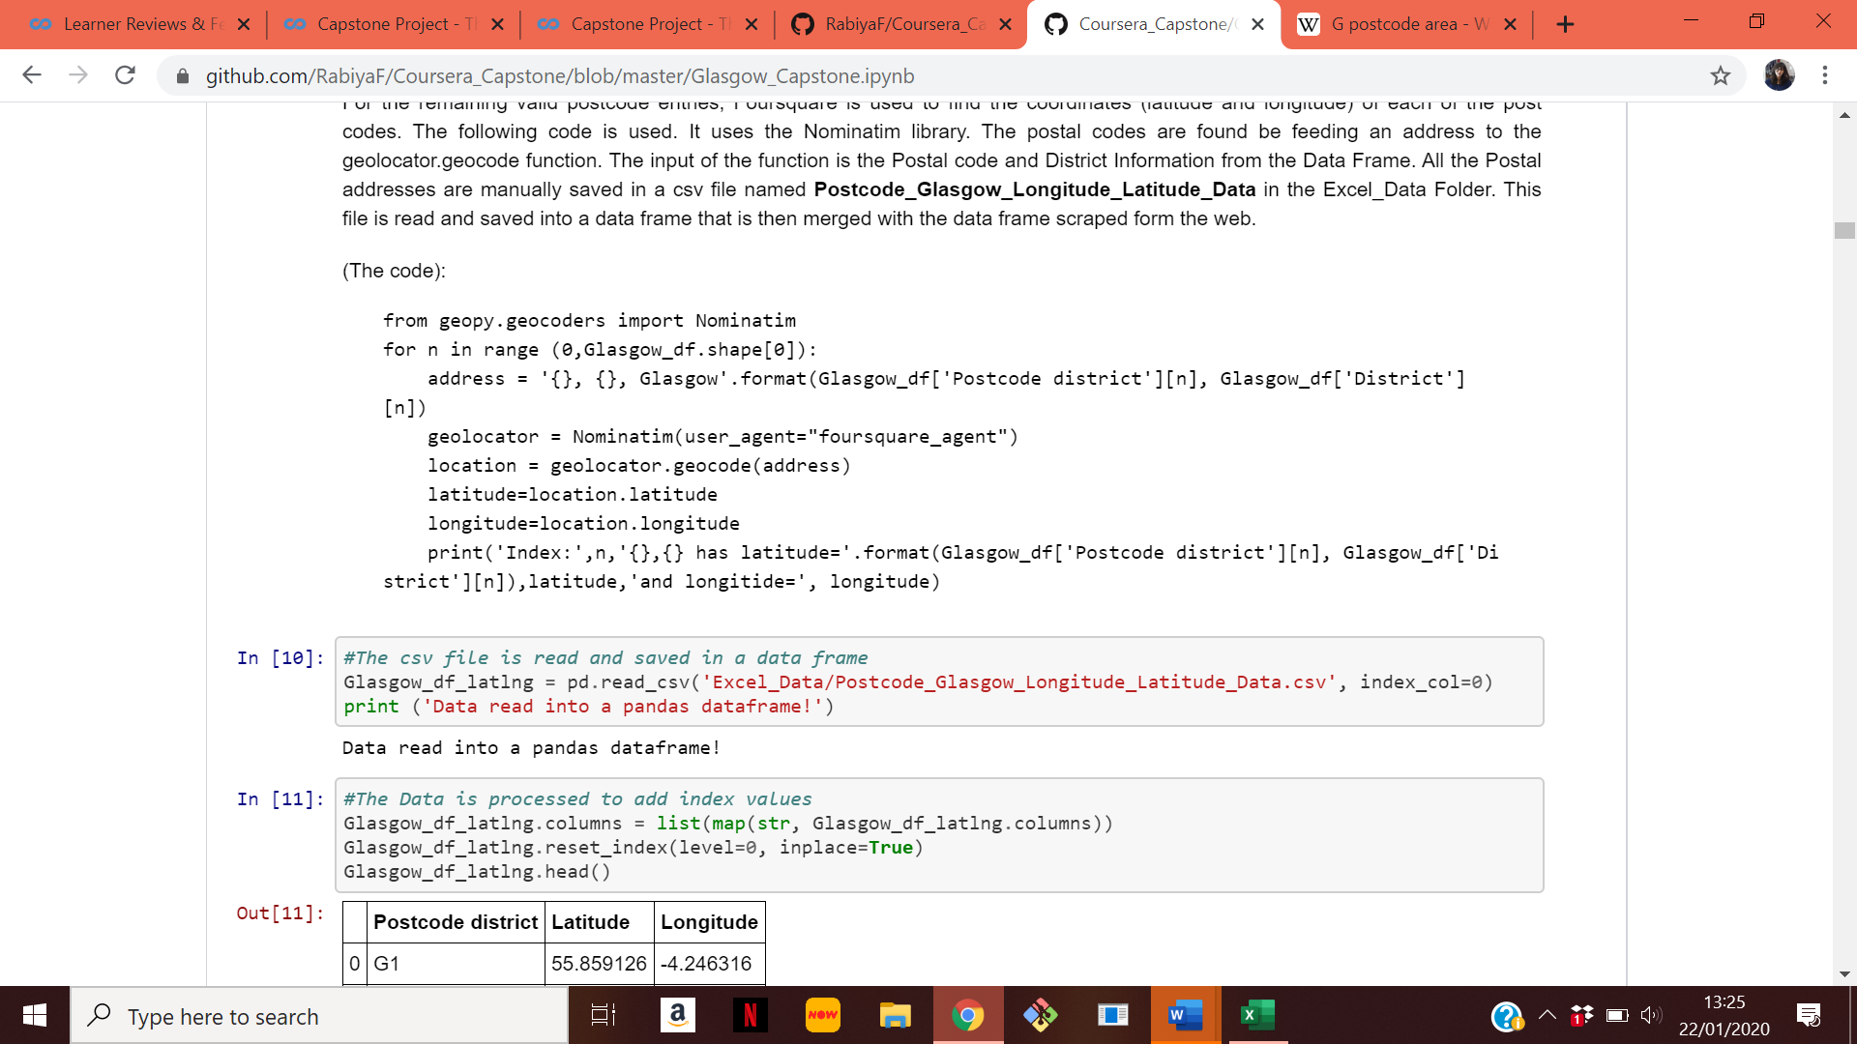

The information retrieved from the foursquare agent is saved in a csv file. This file is then imported and merged with the dataset acquired from the Wikipedia webpage. The final postal code dataframe is given below.

**Table (1): The list of all post codes**

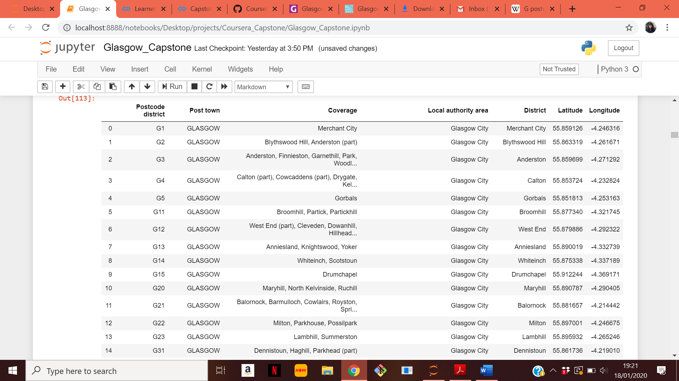

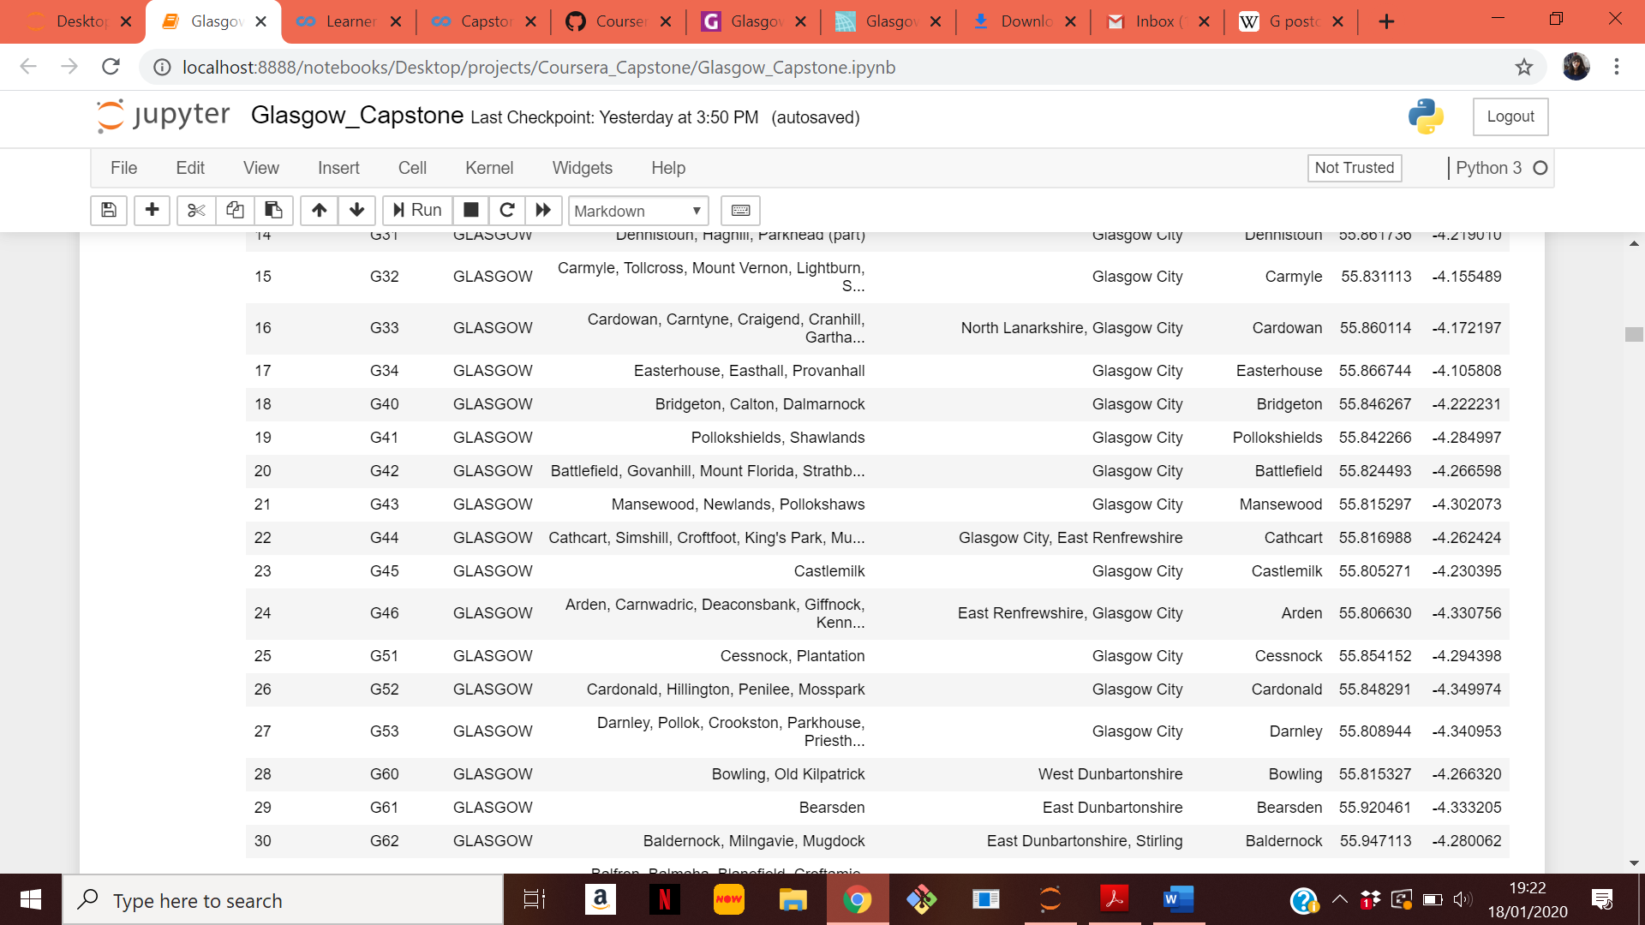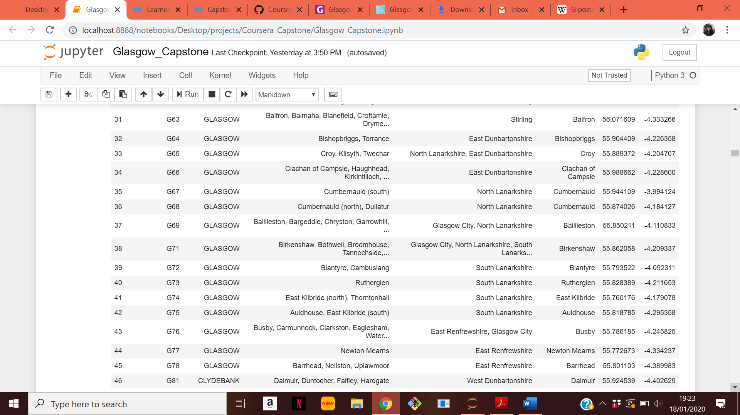

  
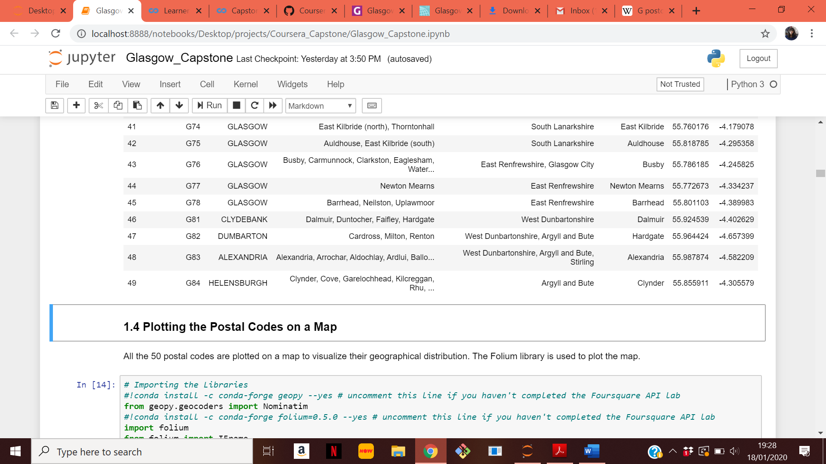

The 50 postcodes are plotted on a map using the folium library. They are shown in Figure 1. As can be seen from the map, the postal codes are dispersed over a very large area. As most of the economic activity in Glasgow is near the city centre, Postal codes that are closer are considered more suitable locations for opening businesses because of their higher exposure to a greater client base.

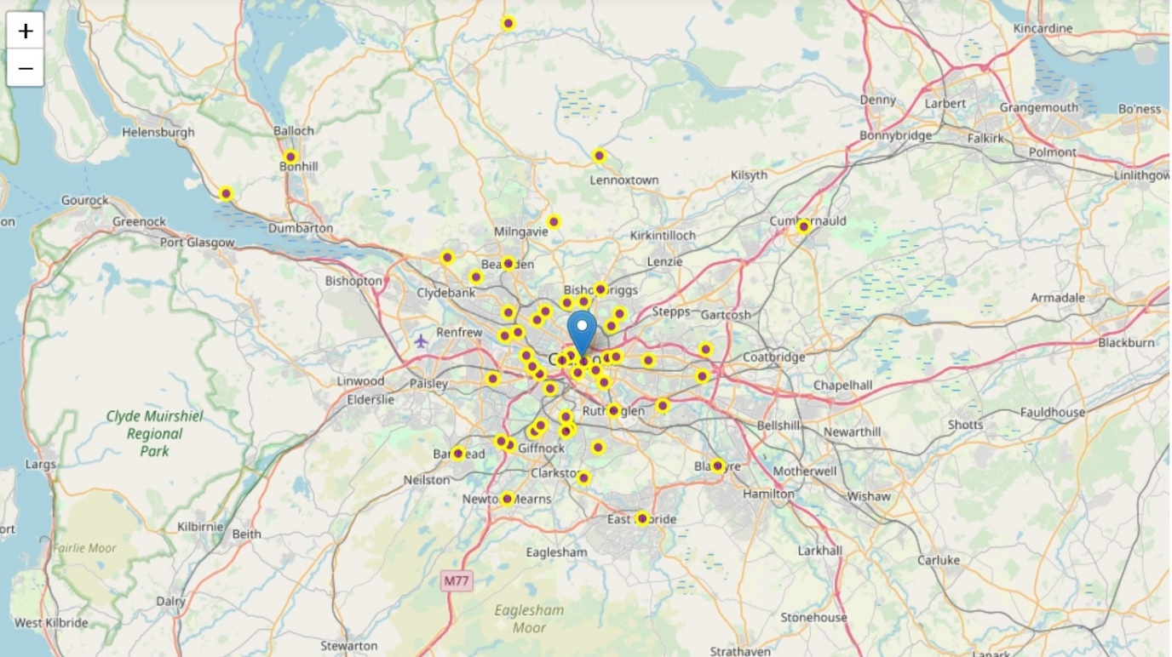  
**Figure (1): All the G Postal codes in Glasgow**

In order to shortlist the postal codes for clustering, the distance to the city centre is needed. There is no dataset available for the distance of a postal code to the Glasgow city centre. So, this is determined by finding the geographical coordinates of the city centre (using geolocator.geocode) and then using the haversine formula to find the distance between the latitude and longitude of the city centre to those of each of the 50 postal codes. The function used for this is given below.

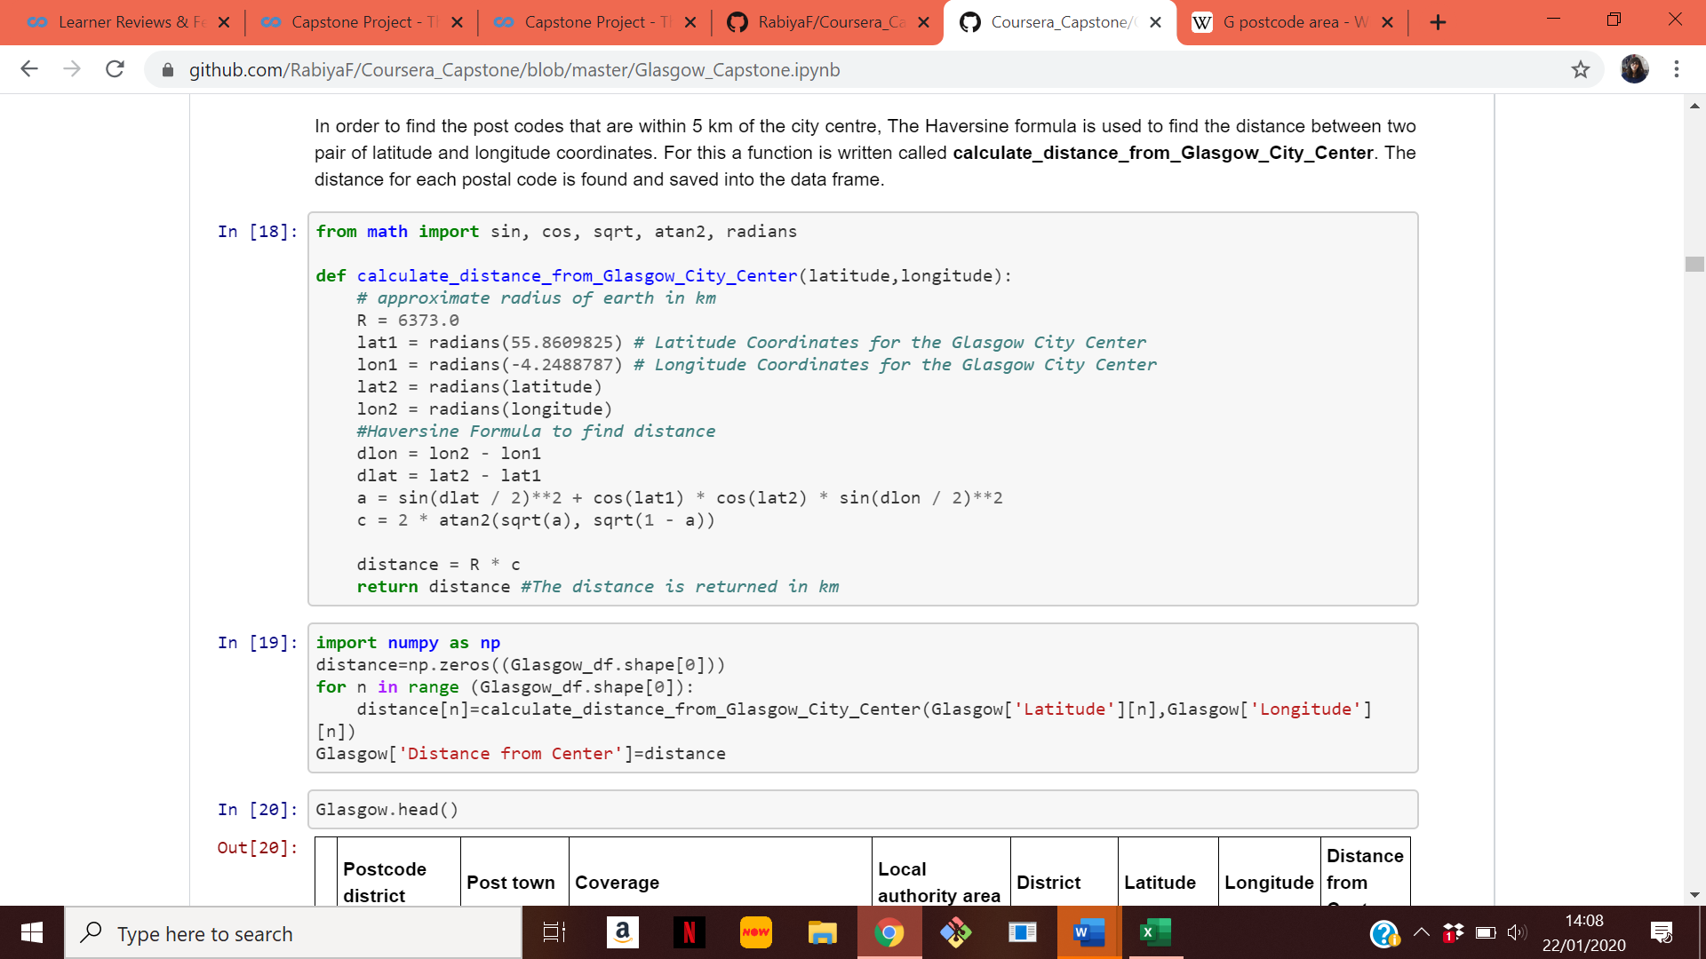

Postal codes that are within 5 km of the city centre are considered for further analysis. The rest are dropped from the dataframe because of the lower business exposure they offer. Out of the 50 postcodes, only 22 postal codes are within 5 km of the city centre. These postcodes are shown in the map in figure (2).

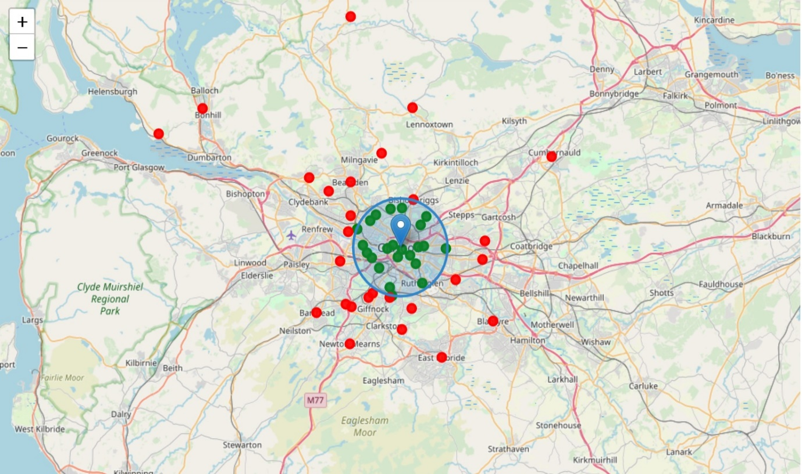  
**Figure (2): Postal codes that are within 5 km of the City Centre**

**Dataset 2:** The addresses of the Glasgow Subway station and the latitude and longitude of those subway station. This data set is acquired from a publicly available dataset and the FourSquareAPI.

This dataset is publicly available from the Glasgow City Council at this link [6]. The dataset contains 14 information parameters. The dataset is given below.

**Table (2): The Subway addresses dataset**

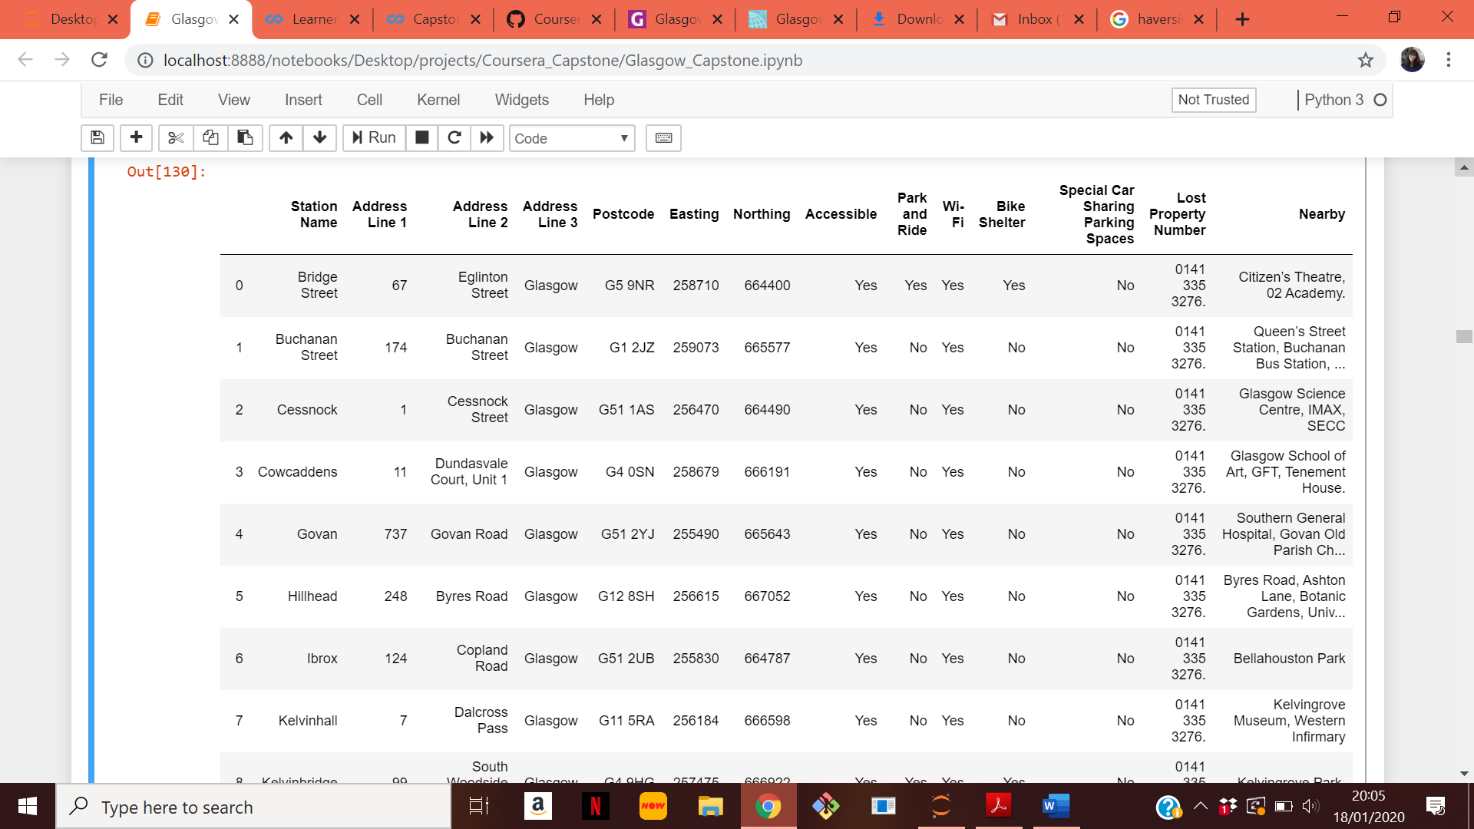  
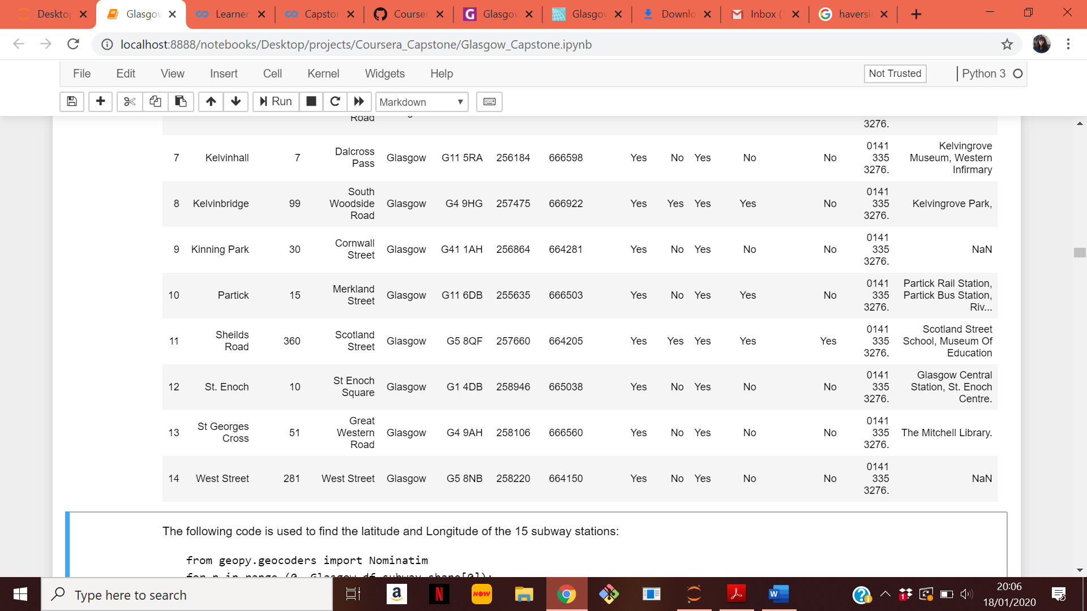

This dataset lists the addresses of the 15 subway stations in Glasgow. In order to find the geographical coordinates, the addresses are fed to the geolocator.geocode function. The information acquired from the FourSquare agent is saved in an excel file which is then imported and merged with the data frame shown above. The location of the 15 subway stations are shown in figure (3). Area within 2 km of the subway station is shaded blue.

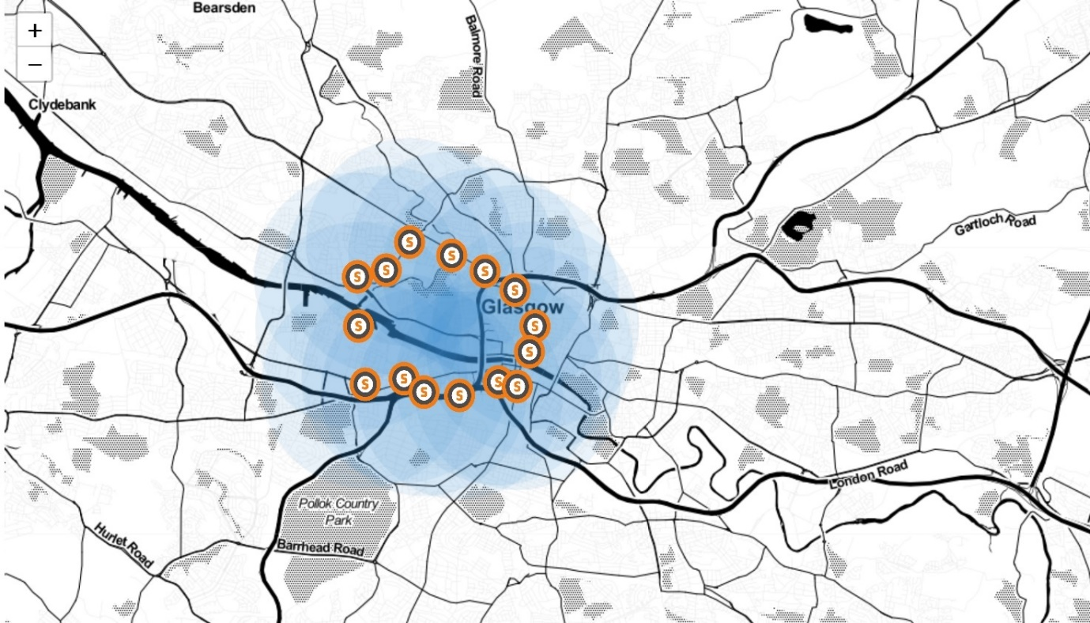  
**Figure (3): The location of the 15 subway stations in Glasgow**

In the 2018-2019 period, 13.1 million passenger journeys were recorded by the Glasgow subway company SPT [4]. As subways are a popular mode of transport in the city of Glasgow, areas around the subway station are suitable places to start a new business within the city. In order to find the distance of a postal code to the nearest subway station the following function is used. It returns the distance to the nearest subway station in km and the name of the nearest station.

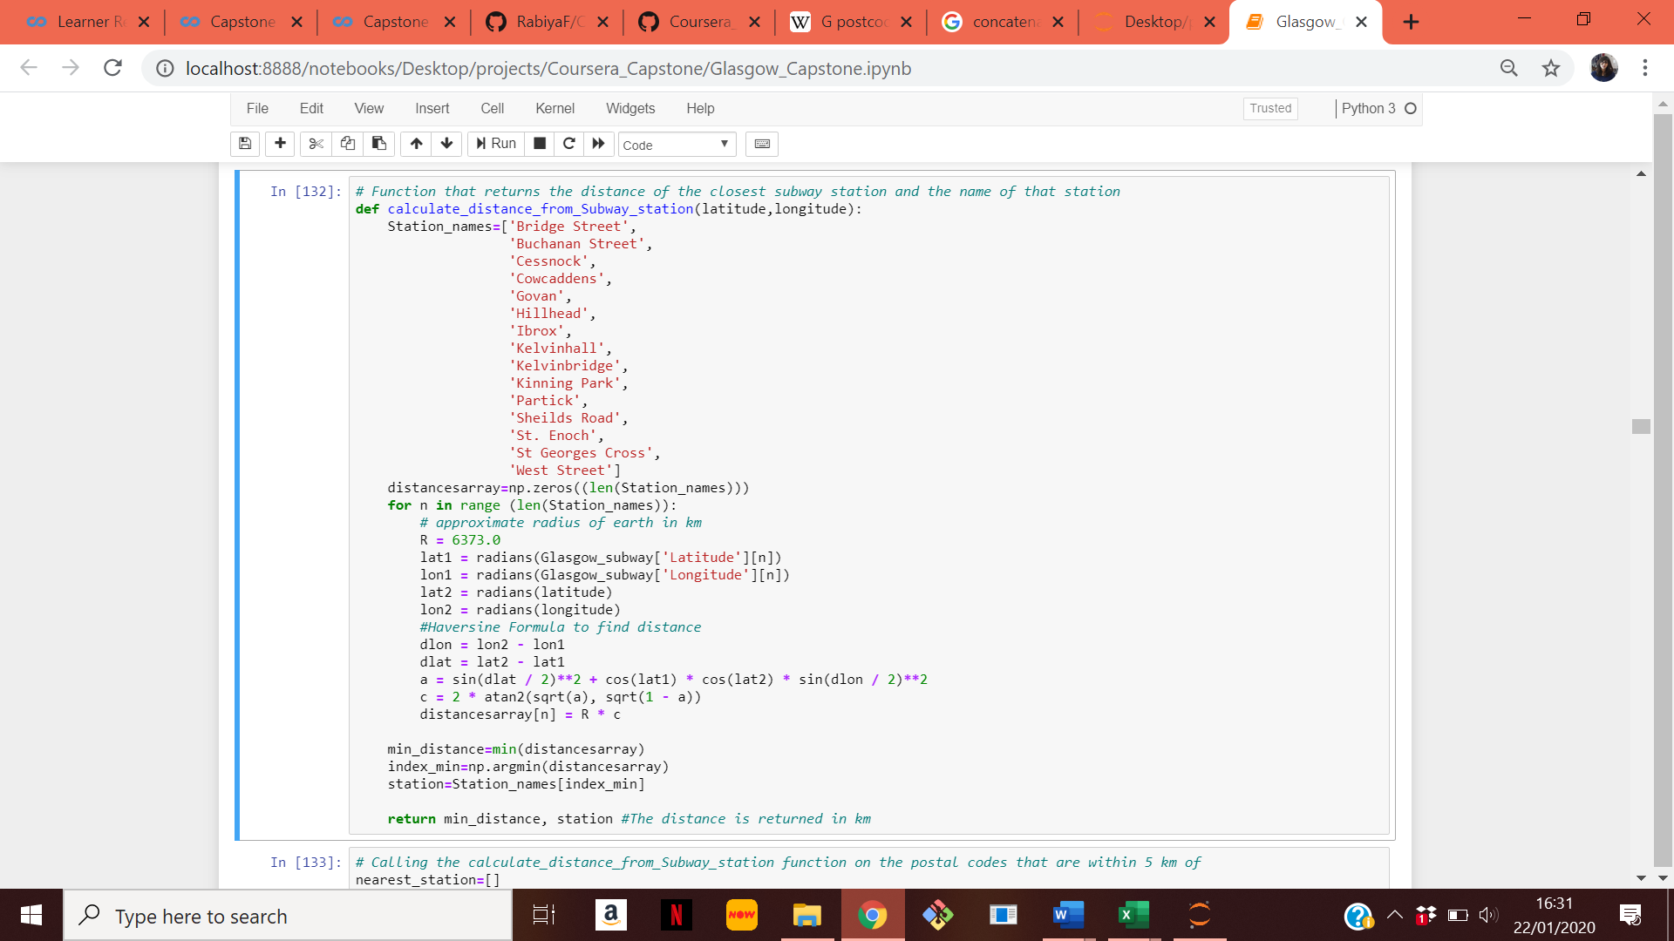

Out of the 22 postal codes that are shortlisted on the basis of distance from the city centre, only 10 are within 2 km of a subway station. They are shown in figure (4) as green dots. The final 10 postal codes are shown in table (3).

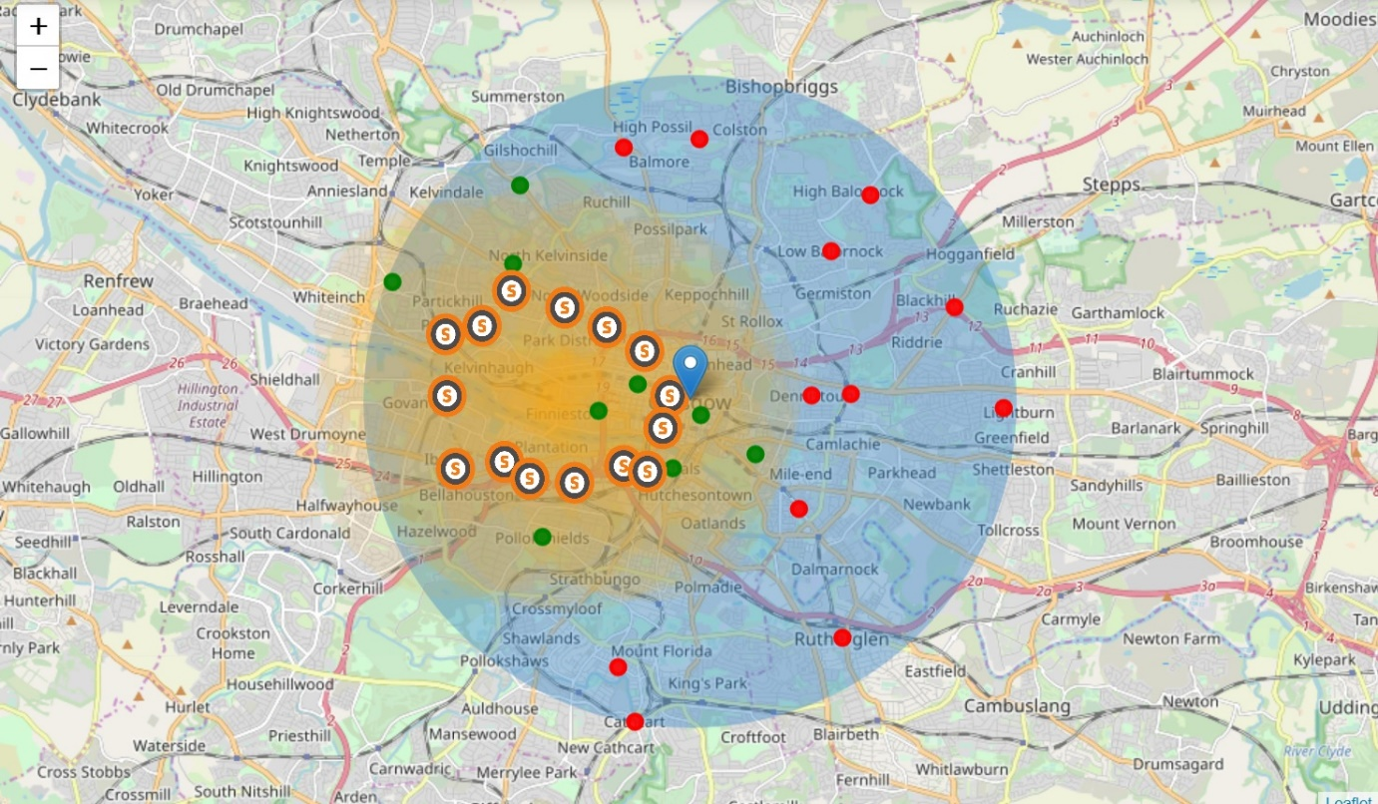  
**Figure (4): The postal codes that are within 5 km of the city centre and that are 2 km from the subway station.**

**Table (3): The list of postal codes that are within 5 km of the city centre and that are within 2 km of the postal codes**

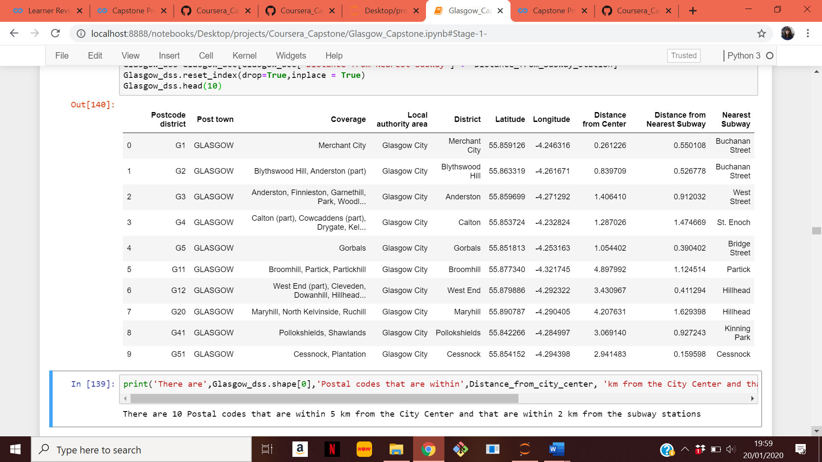

**Dataset 3 and 4:** The Royal mail dataset and the Glasgow City Council dataset. These are publicly available datasets

There is no dataset that maps postal codes directly to population and ethnicity data. Hence in order to extract this information two datasets are used. The first dataset is a Royal mail dataset [7]. This data set contains all the postal codes in Glasgow. It has almost 15,000 data entries. It maps the postal codes in Glasgow to the corresponding datazones. This dataset contains seven parameters of information. They are:

* Postcode unit
* Type of Postcode,
* Sector Community Planning Partnership
* Multi member Ward/ Local Area Partnership
* Data Zone
* Data Zone Rank (SIMD 2012)
* Is this in a bottom 15% Data Zone?

The first five rows of the data frame are shown below. The dataset is processed in order to extract the unique Data zones of each postal district.

**Table (4): Royal Mail Dataset**

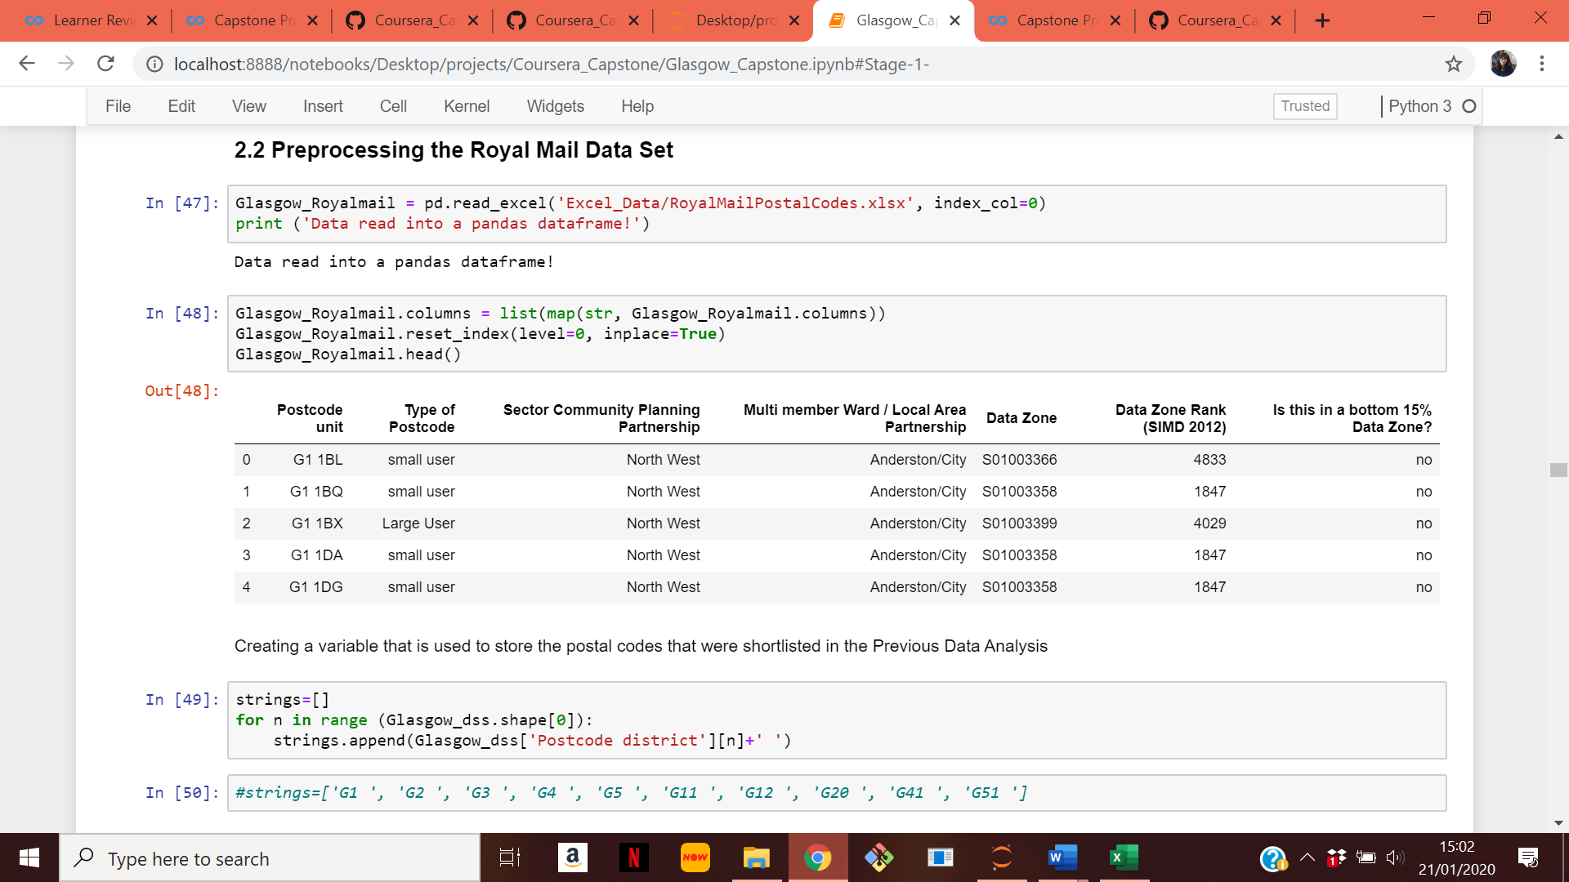

Once the unique data zones of each postal code are obtained, the population and the ethnicity of the population at the postal codes is found using the Glasgow City Council data set [8]. The data set has almost 6200 entries. It is processed in order to extract and sum the population statistics of the data zones of each of the postal code. Firstly, the information regarding the total population is extracted. Next, the number and percentage of White, Asian, African and Other population living at each postcode is also extracted. The extracted dataset for the 10 postal codes is shown in table (5). This information will later be inputted to the unsupervised machine learning algorithm for clustering.

**Table (5): The Extracted population information**

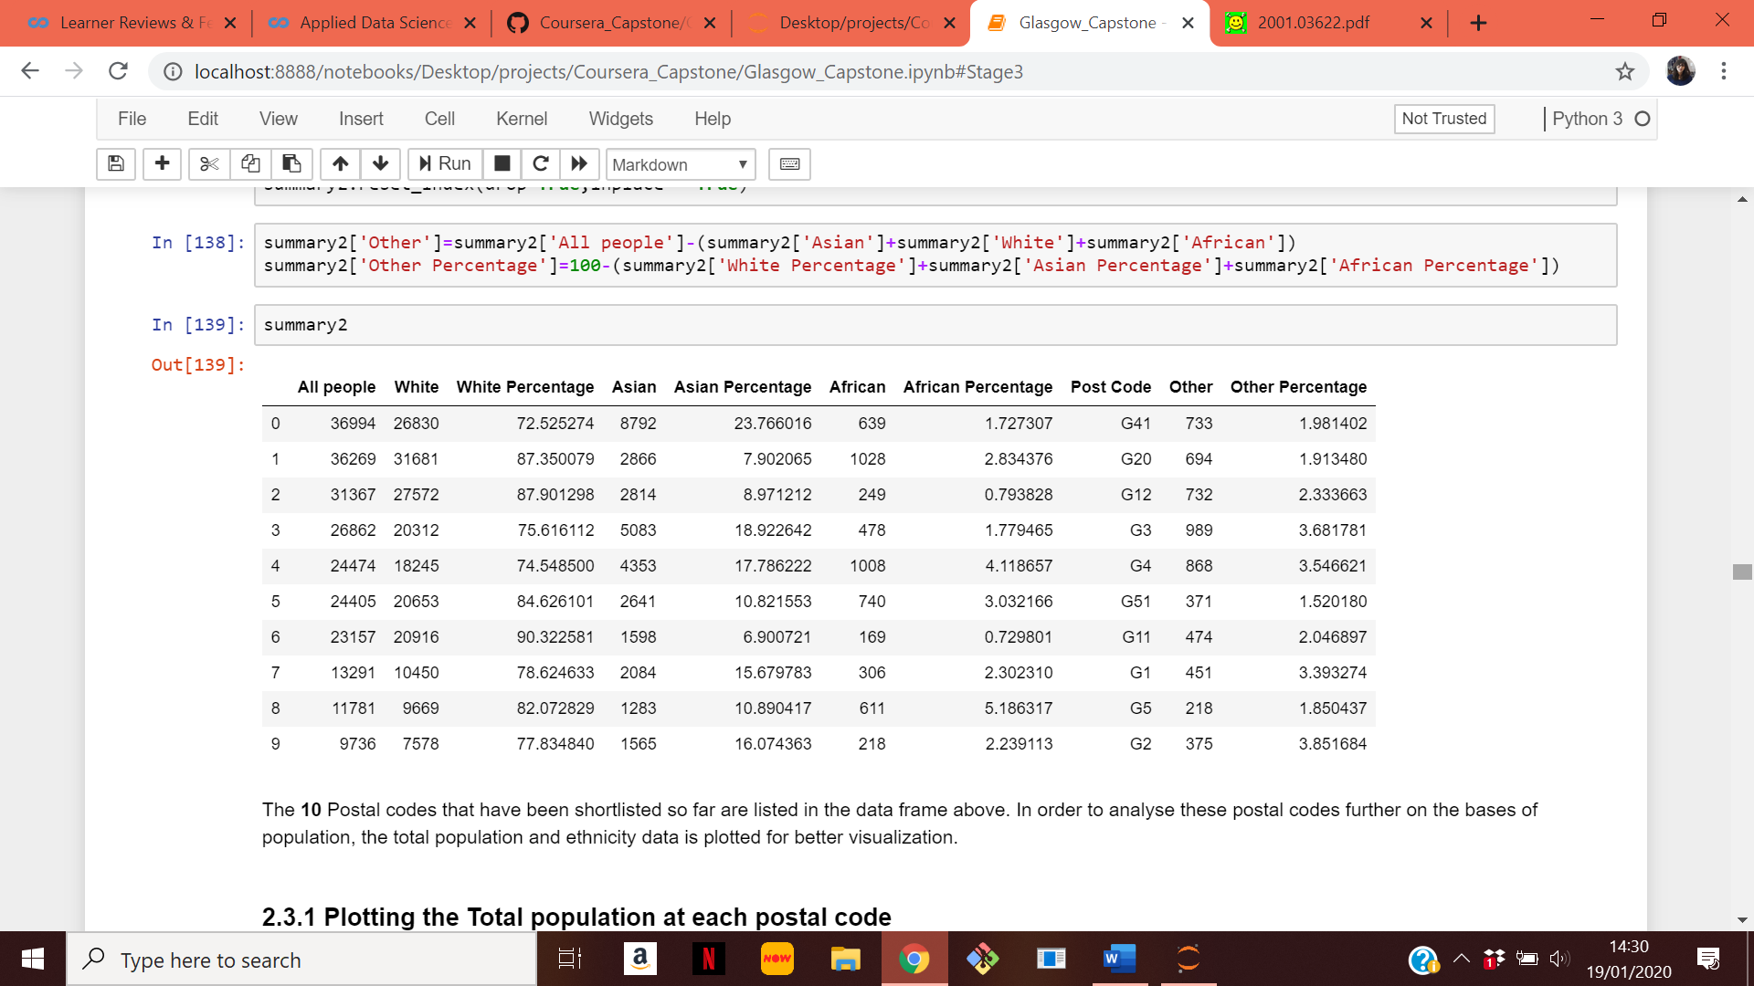

This information is plotted in order to better understand the population characteristics of each post code. The population at the 10 shortlisted post codes is shown in figure (5) in descending order of total population. G41, G20 and G12 each a population of over 30,000 people.

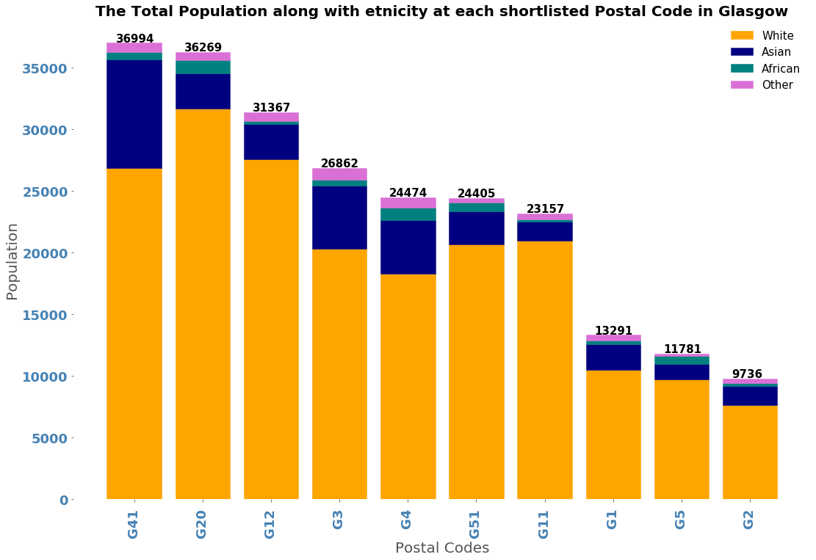  
**Figure (5): Total populations at each postcode**

The top three ethnicity percentages of the population are plotted in figure (6) below. The figure shows that some postal codes have very similar ethnicity percentages.

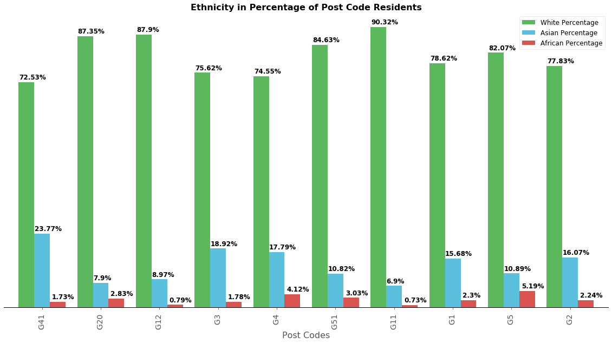  
**Figure (6): Ethnicity breakdown at each postal code**

In order to better visualize the similarity of the ethnicities at each postal code, doughnut plots of ethnicity percentages are plotted in figure (7). As can be seen from the doughnut plots, some post codes have similar population diversity like G12 and G11. This similarity maybe due to the geographical proximity of the postal codes to each other. G4 and G3 are neighbouring postal codes and they have similar population diversity as well. In order to better cluster these postal codes, machine learning will be used.

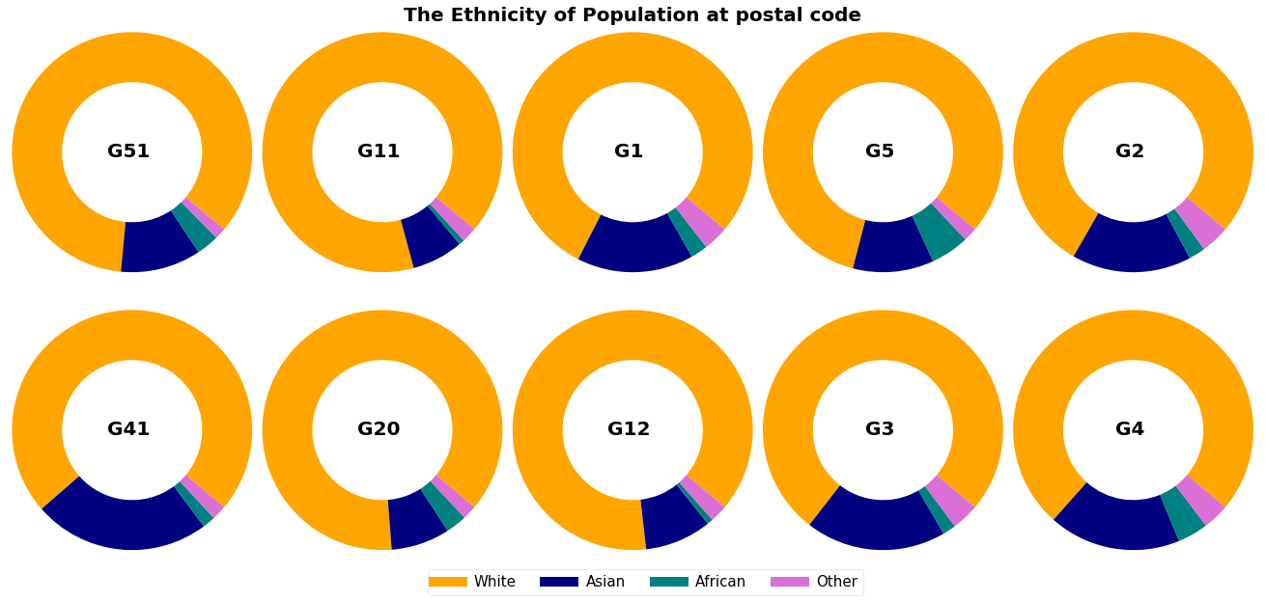

**Figure (7): Ethnicity doughnut plots of each postal code**

**Dataset 5:** The venues data. This data set is acquired from the Foursquare API.

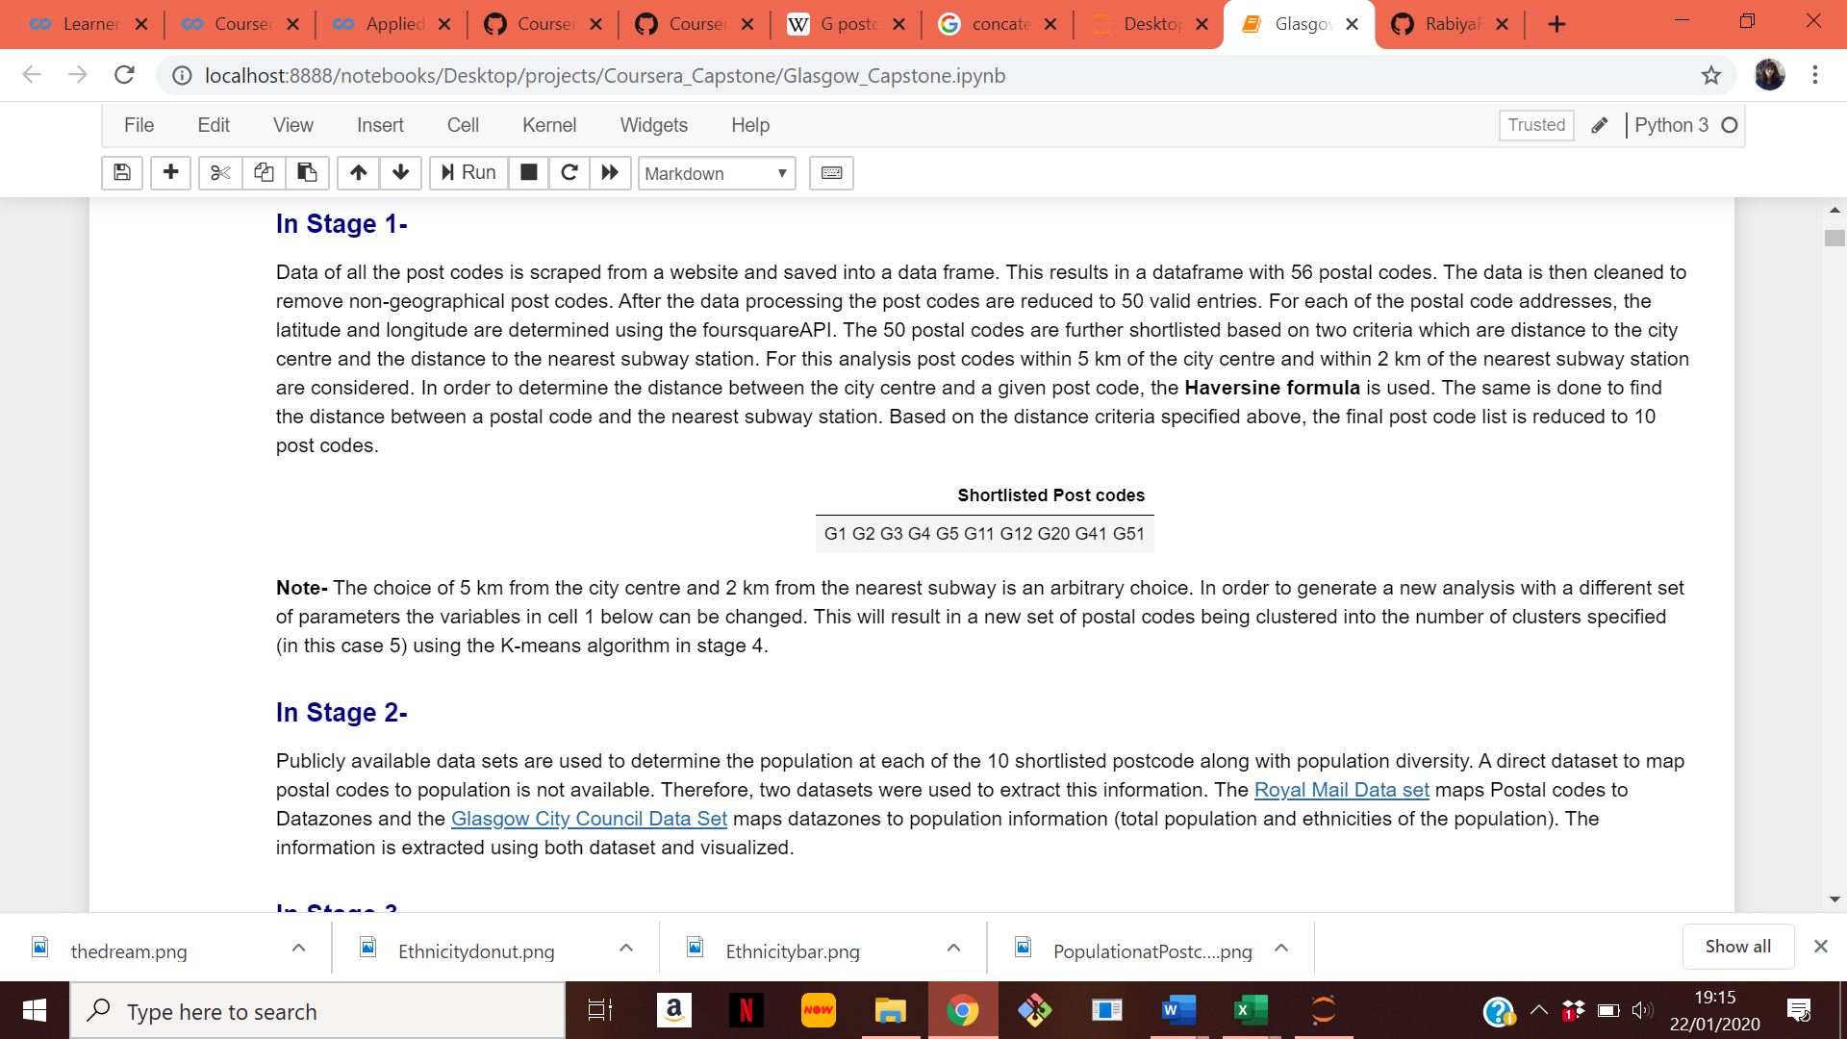

The final shortlisted postcodes are listed in the table above. Venues in these ten postal codes are extracted. All venues within a 1.5 km radius of the postal code are imported from the API. The search area is shown as purple in the map below.

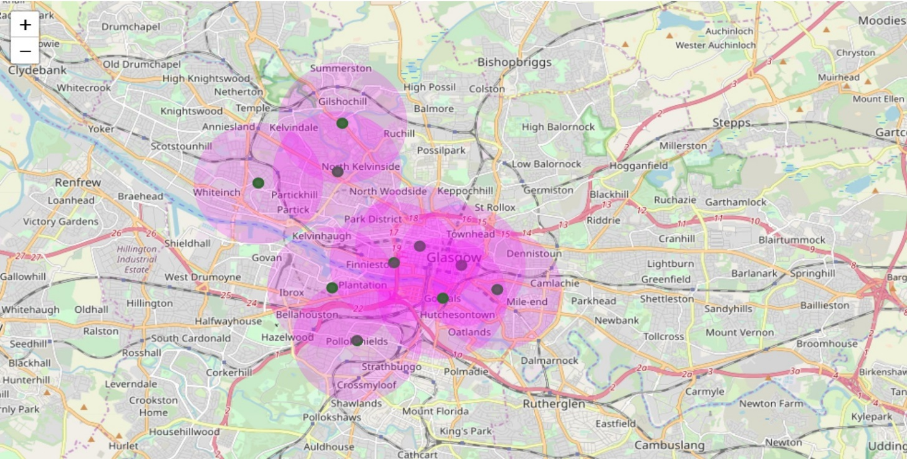  
**Figure (8): The search area for the venues**

Other postal codes border the shortlisted postal codes. So, when 1.5 km radius is specified as a parameter of search in the Foursquare API, it might result in returning venues that belong to the neighbouring postal codes as well. These venues will be removed in the data processing stage. Also, there is a lot of overlap between the areas of search. Therefore, the FourSquareAPI will return the same venues multiple times. The repeating entries will be removed in the data processing stage. The API returns a total of 786 venues. The breakdown of the venues is given in the table below.

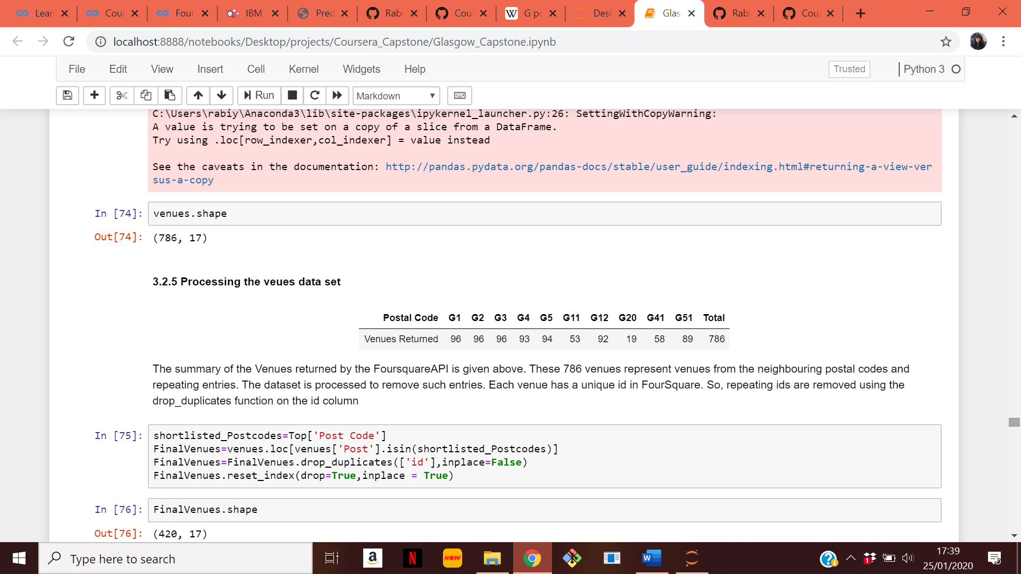

The 786 data entries are processed in order to remove the repeating venues. This reduces the dataset to 420 unique venues in the 10 postal code. The venue categories are one-hot encoded. The one-hot encoded venues dataframe is merged with the population data and then fed into an unsupervised learning algorithm (K-means) for clustering into 5 categories. The clusters are then examined to find possible business opportunities at each postal code.

**Methodology**

The project is divided into 4 stages. The stages are explained in detail below.

**Stage 1-**

In this stage, the postal codes are shortlisted based on whether they are 5 km from the city centre and whether they are within 2 km of a subway station. The first step of the project is to import the list of all the postal codes from the Wikipedia webpage in [5]. This dataset is imported using the BeautifulSoup library. The imported dataset is processed to remove the non-geographical postal codes. This reduces the data set to 50 valid entries. Next, the latitude and longitude of each postal code is found using the geolocator.geocode function. This information is then merged with the original data frame.

Like many big cities, most of the economic and business activity in Glasgow is focused around the city centre. Postal codes that are closer to the city centre are considered more suitable locations for opening businesses because of the myriad of opportunities that they offer business owners. In order to shortlist the postal codes, the distance to the city centre is determined by using the geographical coordinates of the city centre and the haversine formula to find the distance between the city centre and each of the 50 postal codes. Only the 22 Postal codes that are within 5 km of the city centre are considered for further analysis.

In order to further shortlist the postal codes, Dataset 2 is imported. It is publicly available at [6]. It contains the addresses of each of the 15 stations in Glasgow. The addresses are fed into the geolocator.geocode function to find the latitude and longitude of each of the subway stations. In order to find the postal codes that are within 2 km of the subway stations, the haversine formula is used to find the distance of each postcode to the nearest subway station. Out of the 22 postal codes, only 10 meet this requirement. These 10 postal codes are the ones whose population characteristics are analysed in stage 2.

**Stage 2-**

In this stage of the project, the population data is extracted using two datasets. The first dataset used is the Royal Mail dataset found at [7]. This dataset maps the postal codes to data zones. It is used to find the unique data zones for each of the 10 postal codes. The second dataset is the Glasgow City Council dataset which contains the population data collected in the last national census. This dataset maps data zones to population. So, in this stage of the project the unique data zones collected from the royal mail dataset is used to sum the population statistics for each of the postal code. The data extracted from the datasets are

* All people (total population at post code)
* White (total number of people having White ethnicity)
* White Percentage (Percentage of people at post code having White ethnicity)
* Asian (total number of people having Asian ethnicity)
* Asian Percentage (Percentage of people at post code having Asian ethnicity)
* African (total number of people having African ethnicity)
* African Percentage (Percentage of people at post code having African ethnicity)
* Other (total number of people having ethnicity other than White, Asian and African)
* Other Percentage (Percentage of people at post code having ethnicity other than White, Asian and African)

This information along with the top venues in each of the postal code are feed into an unsupervised machine learning algorithm for clustering into five categories.

**Stage 3-**

In this stage of the project, all venues information at each of the 10 postal codes is extracted. The search area of 1.5 km around the postal codes is defined as the search area. The credentials are defined to communicate with the API. The API is used to explore a location using the url below.

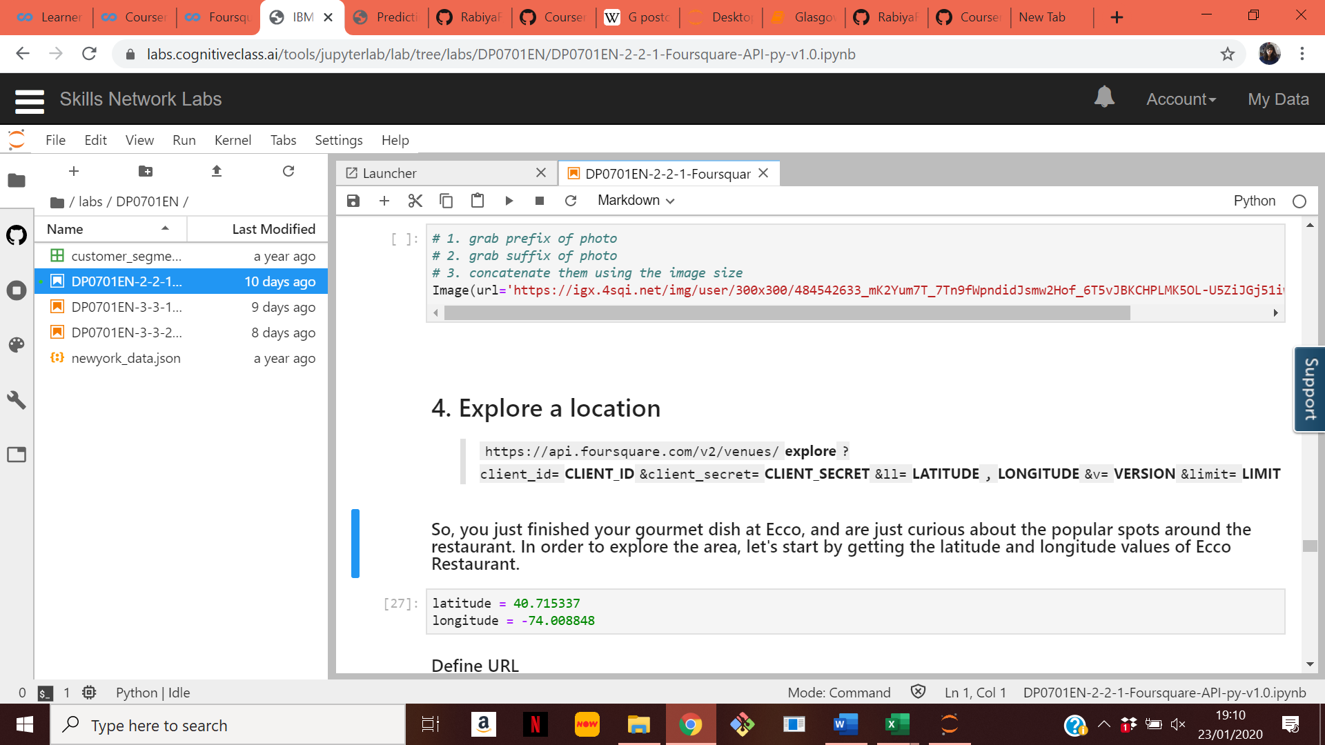

The limit is set as 100 for each postal code. The API returns the venues within 1.5 km of each postal code location. Due to the area overlap, venues are returned multiple times. Venues from the neighbouring postal codes are also returned. A total of 786 venues are returned. These are processed to remove venues from neighbouring postal codes and the repeating venues. There are 420 unique business venues in the ten shortlisted postal codes. There are 112 unique venue categories these will be one hot encoded in the next stage.

**Stage 4-**

The first three stages of the project are mainly focused with data extraction and transformation. In this stage, the data sets extracted in the previous stages are prepared, normalized and merged to be fed into the unsupervised learning algorithm. The K-means algorithm is used to group the postal codes based on their similarities to each other. The categories of the venues are one-hot encoded. The population dataset is normalized. The one-hot encoded venue categories dataset and the population characteristics dataset are merged. This is feed to the K-means clustering algorithm. The results of the clustering algorithm are discussed in the next section.

**Results**

The top five venues of each of the ten post codes are determined. The table below shows the results. Food venues are common in most of the Postal codes except for G51 and G5.

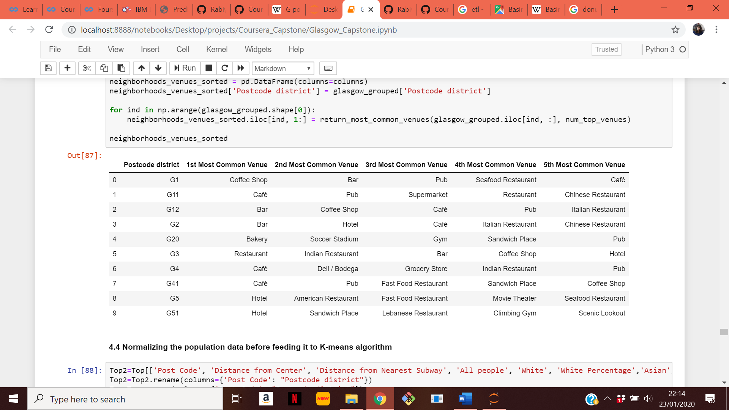

The venues data and the population data are fed to the K-means clustering algorithm. The 10 shortlisted postal codes shown above are clustered into 5 categories. The results of the clustering by the unsupervised machine learning algorithm are given in the table below. The five clusters are colour coded and shown in the map in figure (9).

|  |  |  |  |  |  |  |  |  |  |  |
| --- | --- | --- | --- | --- | --- | --- | --- | --- | --- | --- |
| **Postal Code** | **G3** | **G4** | **G41** | **G5** | **G51** | **G11** | **G12** | **G1** | **G2** | **G20** |
| **Cluster Number** | 1 | 1 | 1 | 2 | 2 | 3 | 3 | 4 | 4 | 5 |
| **Colour on map** | **Red** | **Red** | **Red** | **Purple** | **Purple** | **Blue** | **Blue** | **Green** | **Green** | **Orange** |

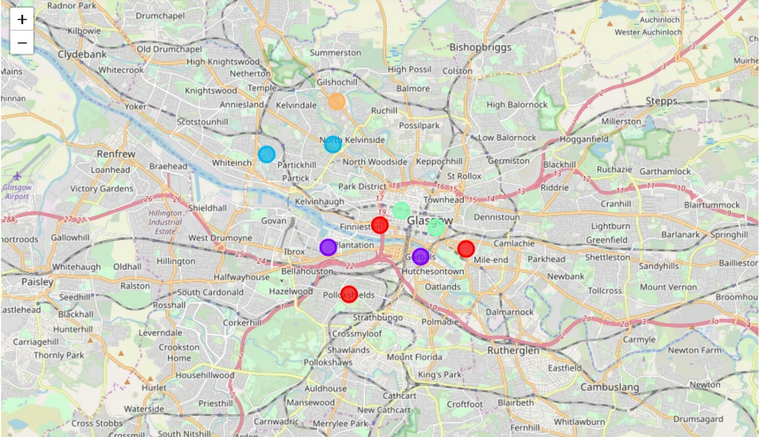  
**Figure (9): Clustered postal codes**

**Discussion**

In this section, similarities between the postal codes in the cluster are identified and possible opportunities in those clusters are also identified for businesses.

**Cluster 1: G3, G4, G41**

This Cluster has member postal codes with the highest population diversity. It seems that food related venues are really common in these postal codes.

**Possible Opportunities at these postal codes-** This cluster has among the highest Asian Population density in Glasgow. Asian themed businesses are likely to succeed in these three postal codes. So, these three postal codes G3, G4 and G41 are recommended as venues for new Asian businesses.

**Cluster 2: G5, G51**

This cluster has a lot of hospitality and entertainment related venues.

**Possible opportunities at these Post codes-** At these postal codes there are not a lot of bars/pubs. So, in G5 and G51 new bars and pubs will face little competition. So, they are identified as possible business opportunities in this cluster.

**Cluster 3: G11, G12**

This cluster has medium total population and low diversity. Food related venues are common in this cluster.

**Possible opportunities at these Post codes-** These Postal codes are close to one of the largest universities in Glasgow. So, G11 and G12 offer opportunities for student service businesses like books, stationary, printing etc. These businesses have the potential to succeed in this area and have little competition at these post codes.

**Cluster 4: G1, G2**

These post codes have low population and medium diversity. Food related venues are common in this cluster. These postcodes also have the lowest distance from the city centre.

**Possible opportunities at these Post codes-** In this cluster, postal codes are near the city centre. So, at G1 and G2 there are opportunities for businesses that want to provide services to tourist like tour operators, souvenir shops etc.

**Cluster 4: G20**

This cluster has only one member. It is furthest away from the city centre and has a high population.

**Possible opportunities at this Post code-** This post code lacks entertainment venues. So new business can explore opportunities like opening a movie cinema or music venue at G20. This might be popular with residents who do not like travelling all the way to the city centre for entertainment.

**Conclusion**

In this Project, publicly available datasets from the Glasgow City Council and the Royal Mail are used alongside data collected from the FourSquareAPI in order to obtain data driven insight into possible business opportunities in Glasgow and the best venues for those opportunities. The summary of the results are as follows.

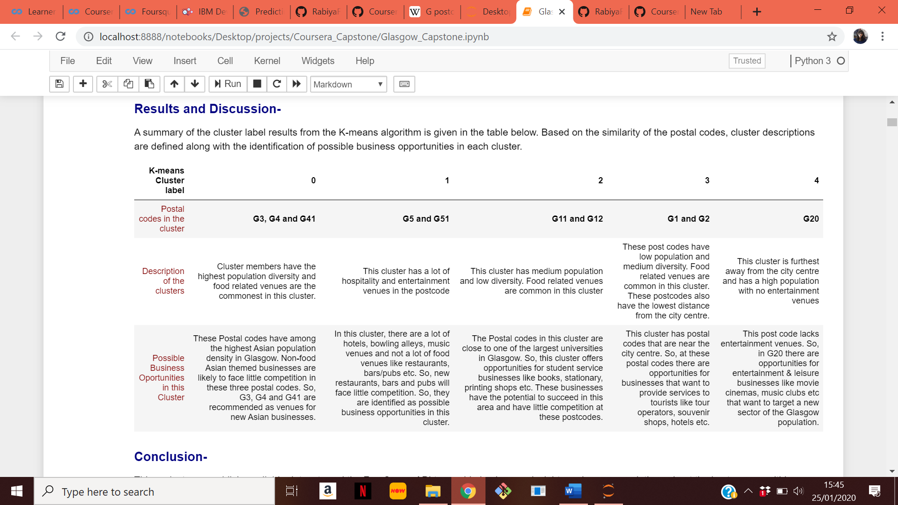

G3, G41 and G4 are suitable for Asian non-food businesses. G5 and G51 are suitable for opening bars and pubs. G11 and G12 are suitable fore businesses targeting students. G1 and G2 are suitable for businesses targeting tourists. G20 is suitable for entertainment related businesses.

**References:**

[1] <https://www.citypopulation.de/en/uk/scotland/glasgow_city/S19000899__glasgow/>  
[2] <https://www.glasgowlive.co.uk/news/glasgow-news/glasgows-population-continues-rise-the-14550988>  
[3] <http://www.spt.co.uk/documents/latest/rtp220618_agenda6.pdf>  
[4] <https://www.statista.com/statistics/305479/passenger-journeys-on-the-glasgow-underground-united-kingdom-uk/>  
[5] <https://en.wikipedia.org/wiki/G_postcode_area>  
[6] <https://data.glasgow.gov.uk/dataset/glasgow-subway-station-locations/resource/8c057567-55e7-4631-ae77-e37b4a0562e8>  
[7] <http://www.glasgow.gov.uk/CHttpHandler.ashx?id=16002&p=0>  
[8] <https://data.glasgow.gov.uk/dataset/national-identity-by-ethnic-group-2011-census>